Practical - 4

Task - 1:
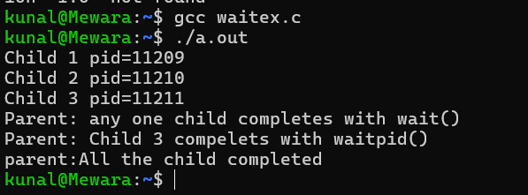

Task - 2:
Practical4.c
Terminal 2: 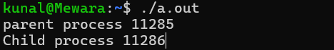
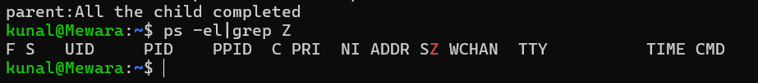
Eliminate practical4.c Process:

Terminal 2:

